The source was not found, but some or all event logs could not be searched. Inaccessible logs: State.

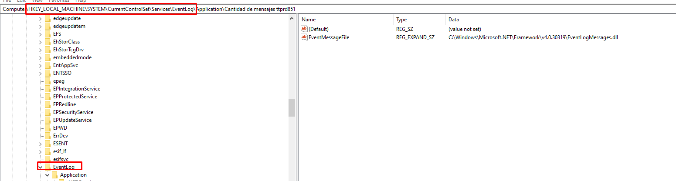

https://www.biztalkgurus.com/blogs/msft-biztalk-community/requested-registry-access-is-not-allowed/

|  |
| --- |
| Requested registry access is not allowed  by [community-syndication](https://www.biztalkgurus.com/author/community-syndication/) | Dec 8, 2006 | [BizTalk Community Blogs via Syndication](https://www.biztalkgurus.com/blogs/msft-biztalk-community/) | [0 comments](https://www.biztalkgurus.com/blogs/msft-biztalk-community/requested-registry-access-is-not-allowed/#respond)  At the project I am working on I mainly use the Event Log to write progress statements from my orchestrations. On my develop-machine I ran into the error message ‘Requested registry access is not allowed’.  It appeared that the user account under which the processing host runs, did not have enough authorisations to access the Event Log.  This can be fixed by giving that user account full control to a certain Registry Key. To achieve this you must start the Registry Editor (regedit.exe) and navigate to HKEY_LOCAL_MACHINE\SYSTEM\CurrentControlSet\Services\EventLog. Right click on the node and click ‘Permissions…’. Next add the user account under which the processing host runs and give this user full control. Close the dialog and the Registry Editor and finally restart the processing host.  You should now be able to write to the Event Log. |

Agregue el usuario del HostInstance y reinicielo

